San Joaquin County

Plausible Threat 2016

Tabletop Exercise -

Multi-Casualty Branch Operations

Situation Manual

August 23, 2016

This page intentionally left blank

Table of Contents
Exercise Overview 1
Preface 2
General Information 2
Module 1: Initial Response 5
Module 2: Reinforced Response 8
Module 3: Multi Branch Response 13
Appendix A: Exercise Schedule A-1
Appendix B: Acronyms B-1
Appendix C: Paradise High School Map C-1
Appendix D: EMS/BRN Evaluation Form D-1
Appendix E: Participant Feedback Form E-1

Exercise Overview
Exercise Name | San Joaquin County Plausible Threat 2016 Tabletop Exercise – Multi-Casualty Branch Operations
Exercise Date | August 23, 2016, 0800 to 1200 Hours
Scope | This exercise is a tabletop exercise, planned for four hours at the San Joaquin County Agriculture Center, Stockton, California.
Mission Area | Response
Core Capabilities | - Operational Coordination  - Operational Communications  - Public Health, Healthcare and Emergency Medical Services
Objectives | - Evaluate the San Joaquin County Active Threat and Region IV MCI plans in response to a simulated Active Shooter/Hostile Event.  - Improve participant’s understanding of the San Joaquin County Active Threat and Region IV MCI plans.
Threat or Hazard | Active Shooter/Hostile Event (ASHE)
Scenario | Active Shooter/Hostile Event (ASHE) occurs during a high school football game.
Sponsors | San Joaquin County EMS Agency and San Joaquin Operational Area Healthcare Coalition.
Participating Organizations | All San Joaquin County based pre-hospital care providers (transport and non-transport), San Joaquin General Hospital, (Control Facility), and San Joaquin County EMS Agency.
Point of Contact | Phillip Cook  San Joaquin Emergency Medical Services Agency  P.O. Box 220,  French Camp, CA, 95231  209-468-6818  pcook@sjgov.org

Preface
The Plausible Threat 2016 Tabletop Exercise – Multi-Casualty Branch Operations is sponsored by the San Joaquin County EMS Agency and San Joaquin Operational Area Healthcare Coalition. The exercise was designed to evaluate the San Joaquin County Active Threat Plan and to improve the response, management and mitigation of an Active Shooter/Hostile Event in San Joaquin County. This Situation Manual (SitMan) follows guidance set forth by the U.S. Department of Homeland Security (DHS) Homeland Security Exercise and Evaluation Program (HSEEP).

The Plausible Threat 2016 Tabletop Exercise – Multi-Casualty Branch Operations SitMan provides exercise participants with all the necessary tools for their roles in the exercise. It is tangible evidence of the San Joaquin County EMS Agency’s commitment to preparedness excellence through collaborative planning and exercises that will improve the survivability of victims of an Active Shooter/Hostile Event (ASHE).

The Plausible Threat 2016 Tabletop Exercise – Control Facility Operations is an unclassified exercise. Control of this exercise information is based on public sensitivity regarding the nature of the exercise rather than the actual exercise content. All exercise participants may view the SitMan.

General Information

Participant Roles and Responsibilities
The term participant encompasses many groups of people, not just those playing in the exercise. Groups of participants involved in the exercise, and their respective roles and responsibilities, are as follows:
- Players. Players are personnel who have an active role in discussing or performing their regular roles and responsibilities during the exercise. Players discuss or initiate actions in response to the simulated emergency.
- Observers. Observers do not directly participate in the exercise; however they may support the group in developing responses to the situation during the discussion.
- Facilitators. Facilitators provide situation updates and moderate discussions. They also provide additional information or resolve questions as required. Key Exercise Planning Team members also may assist with facilitation as subject matter experts (SMEs) during the exercise.
- Evaluators. Evaluators are assigned to observe and document certain objectives during the exercise. Their primary role is to document player discussions, including how and if those discussions conform to plans, polices, and procedures.

Exercise Structure
This exercise will be a multimedia, facilitated exercise. Players will participate in the following three (3) modules:
- Module 1: Initial Response
- Module 2: Reinforced Response
- Module 3: Multi-Branch Response

Each module begins with a multimedia update that summarizes key events occurring within that time period. After the updates, participants review the situation and engage in functional group discussions of appropriate response issues. For this exercise, the functional groups are as follows:
- Multi-Casualty Branch
- Control Facility

After these functional group discussions, participants will engage in a moderated plenary discussion in which a spokesperson from each group will present a synopsis of the group’s actions, based on the scenario.

Exercise Guidelines
- This exercise will be held in an open, low-stress, no-fault environment. Varying viewpoints, even disagreements, are expected.
- Respond to the scenario using your knowledge of current plans and capabilities (i.e., you may use only existing assets) and insights derived from your training.
- Decisions are not precedent setting and may not reflect your organization’s final position on a given issue. This exercise is an opportunity to discuss and present multiple options and possible solutions.
Issue identification is not as valuable as suggestions and recommended actions that could improve response efforts. Problem-solving efforts should be the focus.
During exercise discussions, if a player states that they are going to ask for/provide mutual aid, they need to state specifically under which plan and to which agency they will do so.

Exercise Assumptions and Artificialities
In any exercise, assumptions and artificialities may be necessary to complete play in the time allotted and/or account for logistical limitations. Exercise participants should accept that assumptions and artificialities are inherent in any exercise, and should not allow these considerations to negatively impact their participation. During this exercise, the following apply:
- The exercise scenario is plausible, and events occur as they are presented.
- There is no hidden agenda, and there are no trick questions.
- All players receive information at the same time.
- The high school in the scenario is located in the French Camp-McKinley Fire District.

Exercise Evaluation
Evaluation of the exercise is based on the exercise objectives. Players will be asked to complete participant feedback forms. These documents, coupled with facilitator observations and notes, will be used to evaluate the exercise and compile the After-Action Report (AAR).

Module 1: Initial Response

Friday September 23, 2016:

1930 hours
Paradise verses San Joaquin football game begins, hosted by the home team Paradise High School. There are approximately 650 people in attendance.

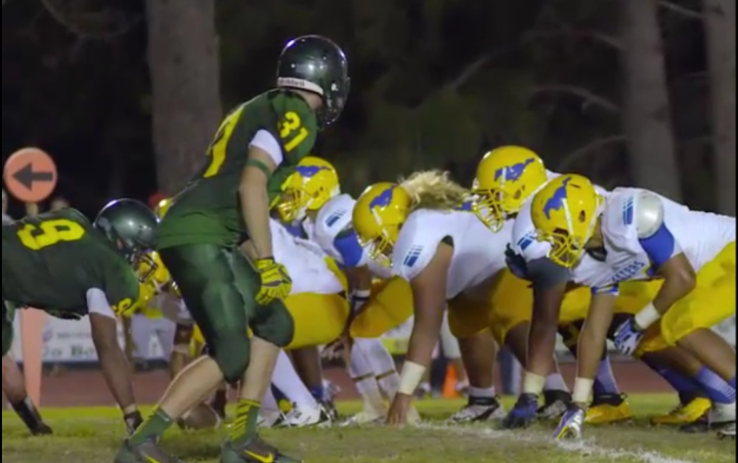
1948 hours
With 6:55 minutes remaining in the second quarter, an explosion in the home team bleachers occurs. Immediately following the explosion, gunshots are heard and several people are shot.

Panic ensues, spectators and players begin running in all directions. The location of the shooter(s) is unknown at this time.

The local PSAPs are inundated with 9-1-1 calls reporting the explosion and shooting. Additional gunshot can be heard in the background by one of the dispatchers receiving a call.

1950 hours
Law, Fire and EMS are dispatched to the incident.

Key Issues
- An unknown number of people have been injured by the explosion and gunshots
- The scene is in chaos
- The location of the shooter(s) is unknown
- The shooting actively continues

Questions
Based on the information provided, participate in the discussion concerning the issues raised in Module 1. Identify any critical issues, decisions, requirements, or questions that should be addressed at this time.

Instructions
Take 20 minutes to discuss the questions below. Assign a group scribe to document your group’s answers and a spokesperson to share your group’s findings.

Multi-Casualty Branch
- Identify the EMS and Fire resources that would be initially dispatched to this incident.

- Identify who the Medical Group Supervisor is

  - Put on the MGS position vest or ID badge to identify yourself

- Identify which MCI / Active Threat positions you would fill at this time and who would fill each position.

Multi-Casualty Branch Director ___________________________
Medical Group Supervisor ___________________________
Triage Unit Leader ___________________________
Triage Personnel ___________________________
Morgue Manager ___________________________
Treatment Unit Leader ___________________________
Immediate Treatment Mgr. ___________________________
Delayed Treatment Mgr. ___________________________
Minor Treatment Mgr. ___________________________
Patient Transportation Group Supervisor ________________________
Medical Communications Coordinator __________________________
Ground Ambulance Coordinator ___________________________
Air Ambulance Coordinator ___________________________
Patient Retrieval Mgr. ___________________________
Litter Bearers ___________________________

  - Assign the positions from the available participants and have them put on position vests or ID badges
- Provide justification your position assignments

- Describe what information would be provided to the Control Facility at this point in the incident.

  - Provide a verbal report to the Control Facility.

Control Facility

- Describe the information you need in order create an MCI event in EMResource.

- Explain the process for determining patient destinations from an MCI.

- What are your concerns at this point in the incident?

Module 2: Reinforced Response

Friday September 23, 2016:

1951 hours

The BLS ambulance on stand-by at the game has left the scene, and notifies dispatch of the situation.

1954 hours
Law enforcement arrives on scene. People are running and screeming as they flee the scene.

Fire and ALS ambulances arrive.

1955 hours
As the Contact Team approaches the football stadium they encounter a suspect with a handgun, who begins shooting at them. The suspect is wounded and is taken into custody. The suspect confesses to planting one bomb in the bleachers and that a second shooter is located on top of the gymnasium.

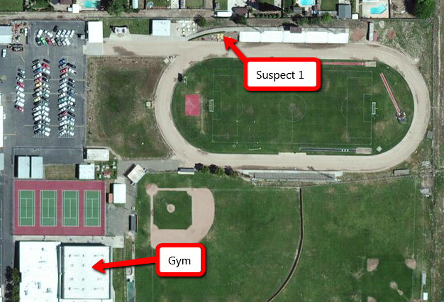

1957 hours

The location of the second suspect is relayed to additional Law Enforcement personnel, who converge upon the gymnasium. A witness runs out of the south door of the gym and reports that there is a guy shooting inside the men’s locker room with a rifle; and that at least three people have been shot.

1958 hours
The current Emergency Department bed poll on EMResource
San Joaquin County | Immediate | Delayed | Minor | Decon Facility | Surgeon Available
Dameron | 1 | 0 | 10 | Yes | Yes
Doctor’s Manteca | 2 | 5 | 10 | Yes | Yes
Kaiser Manteca | 1 | 2 | 5 | Yes | Yes
Lodi Memorial | 2 | 4 | 10 | Yes | Yes
San Joaquin General | 4 | 8 | 20 | Yes | Yes
St. Joseph’s | 4 | 8 | 20 | Yes | Yes
Sutter Tracy | 1 | 2 | 10 | Yes | Yes
Sacramento County | Immediate | Delayed | Minor | Decon Facility | Surgeon Available
UC Davis | 4 | 4 | 20 | Yes | Yes
Kaiser South | 4 | 5 | 10 | Yes | Yes
Stanislaus County | Immediate | Delayed | Minor | Decon Facility | Surgeon Available
Doctor’s Medical Center | 4 | 4 | 20 | Yes | Yes
Memorial Medical Center | 3 | 5 | 10 | Yes | Yes
Totals | 30 | 47 | 145

Key Issues
- One suspect is in custody and has confessed to the bombing
- A second suspect is actively shooting inside the gym
- The number and severity of casualties is unknown

Questions
Based on the information provided, participate in the discussion concerning the issues raised in Module 2. Identify any critical issues, decisions, requirements, or questions that should be addressed at this time.

Instructions
Take 20 minutes to discuss the questions below. Assign a group scribe to document your group’s answers and a spokesperson to share your group’s findings.

Multi-Casualty Branch
- Describe the priorities of the Medical Group or Multi-Casualty Branch at this time

- Describe the additional resources you have requested.

  - What is their estimated time of arrival?

- Identify the locations of the following:
  - Ambulance Staging Area
  - Casualty Collection Point
  - Patient Treatment Areas
    - Immediate
    - Delayed
    - Minor
  - Patient Loading Area

- Which position is responsible for managing the Ambulance Staging area?

- Provide an update for the Control Facility

- Identify which positions would be filled at this time and who would fill each position.
Multi-Casualty Branch Director ___________________________
Medical Group Supervisor ___________________________
Triage Unit Leader ___________________________
Triage Personnel ___________________________
Morgue Manager ___________________________
Treatment Unit Leader ___________________________
Immediate Treatment Mgr. ___________________________
Delayed Treatment Mgr. ___________________________
Minor Treatment Mgr. ___________________________
Patient Transportation Group Supervisor ________________________
Medical Communications Coordinator __________________________
Ground Ambulance Coordinator ___________________________
Air Ambulance Coordinator ___________________________
Patient Retrieval Mgr. ___________________________
Litter Bearers ___________________________

- Describe the criteria for expanding to a Multi-Casualty Branch from a Medical Group.

- Explain your ambulance loading strategy for a large MCI

Control Facility
- Explain if you have enough information to be able to provide the field with preliminary patient destinations at this point

- Assuming the incident has a number gunshot wounds and blast injury victims, where would the first 5 Immediate, Delayed and Minor patients be transported to?

San Joaquin County | Immediate | Delayed | Minor
Dameron
Doctor’s Manteca
Kaiser Manteca
Lodi Memorial
San Joaquin General
St. Joseph’s
Sutter Tracy
Sacramento County | Immediate | Delayed | Minor
UC Davis
Kaiser South
Stanislaus County | Immediate | Delayed | Minor
Doctor’s Medical Center
Memorial Medical Center
Totals

Module 3: Multi-Branch Response

Friday September 23, 2016:

2002 hours

Suspect 2, inside the gym, sends one hostage out with a message for Law Enforcement that he wants to be allowed to leave or he will shoot everyone one inside the gym. The hostage provides the suspect’s cell phone number and reports that there are eight other people inside, three of them have been shot. All victims were still alive when he was sent outside.

Upon further questioning, suspect 1 confirms with there are no other bombs or shooters on-scene.

2003 hours

The Multi-Casually Branch Director has been informed by the Operations Section Chief that the football stadium has been designated as the Warm Zone and the Rescue Task Force is ready to evacuate patients and victims.

2005 hours
Law Enforcement establishes a perimeter around the gym and is attempting to make telephone contact with the suspect.

The Rescue Task Force enters the Warm Zone and begins evacuating patients and victims.

2006 - 2030 hours
Patients are being triaged and are readied for transport as there are transferred to the Triage Group through the Casualty Collection Point

The Patient Transportation Group Supervisor (PTGS) provides the Control Facility with an update and initial patient counts.

2010 hours
Law Enforcement establishes a telephone contact with suspect 2, who is being cooperative.

Key Issues
- The suspect 2 is still holding hostages, but is being cooperative with Law Enforcement.
- There still isn’t an accurate casualty count at this point in the incident.
- Unconfirmed number and status of the victims inside the gym.
- Patients and victims are beginning to be moved out of the Warm Zone by the Rescue Task Force

Questions
Based on the information provided, participate in the discussion concerning the issues raised in Module 3. Identify any critical issues, decisions, requirements, or questions that should be addressed at this time.

Instructions
Take 20 minutes to discuss the questions below. Assign a group scribe to document your group’s answers and a spokesperson to share your group’s findings.
Multi-Casualty Branch

- Identify which positions are filled at this time and who would fill each position.
Multi-Casualty Branch Director ___________________________
Medical Group Supervisor ___________________________
Triage Unit Leader ___________________________
Triage Personnel ___________________________
Morgue Manager ___________________________
Treatment Unit Leader ___________________________
Immediate Treatment Mgr. ___________________________
Delayed Treatment Mgr. ___________________________
Minor Treatment Mgr. ___________________________
Patient Transportation Group Supervisor ________________________
Medical Communications Coordinator __________________________
Ground Ambulance Coordinator ___________________________
Air Ambulance Coordinator ___________________________
Patient Retrieval Mgr. ___________________________
Litter Bearers ___________________________

- Explain who is responsible for moving patients:

  - Warm Zone to Casualty Collection Point

  - Casualty Collection Point to Triage Unit

  - Triage Unit to Immediate, Delayed and Minor Treatment Areas

  - Treatment Areas to the Patient Loading Area

- Provide the Control Facility with an updated patient count

Immediate | Delayed | Minor

- What is the final patient count by START criteria?

Immediate | Delayed | Minor | Deceased

- Describe the process for integrating non-transport paramedics and EMTs into Multi-Casualty Branch operations.

- Explain the process for managing unassigned EMS resources: track, request, demobilize and release.
Control Facility
- Provide the field with patient destinations

San Joaquin County | Immediate | Delayed | Minor
Dameron
Doctor’s Manteca
Kaiser Manteca
Lodi Memorial
San Joaquin General
St. Joseph’s
Sutter Tracy
Sacramento County | Immediate | Delayed | Minor
UC Davis
Kaiser South
Stanislaus County | Immediate | Delayed | Minor
Doctor’s Medical Center
Memorial Medical Center
Totals

Appendix A: Exercise Schedule
Time | Activity
August 23, 2016
0730 - 0800 | Check-In and Registration
0800 - 0815 | Welcome and Exercise Overview
0815 - 0915 | Module 1: Initial Response
0915 - 0925 | BREAK
0925 - 1025 | Module 2: Reinforced Response
1025 - 1035 | BREAK
1035 - 1135 | Module 3: Multi-Branch Response
1135 - 1200 | Hot Wash, Wrap-up and Closing Comments

Appendix B: Acronyms

Acronym | Term
ALS | Advance Life Support
AAR/IP | After Action Report/Improvement Plan
ASHE | Active Shooter/Hostile Event
BLS | Basic Life Support
Cal OES | California Governor’s Office of Emergency Services
CSWC | California State Warning Center
CF | Control Facility
DHS | U.S. Department of Homeland Security
EMAC | Emergency Management Assistance Compact
EMS | Emergency Management Services
EMSA | California Emergency Medical Services Authority
ETA | Estimated time of arrival
FOUO | For Official Use Only
HSEEP | Homeland Security Exercise and Evaluation Program
IC | Incident Commander
ICS | Incident Command System
MCI | Multi-Casualty Incident
MGS | Medical Group Supervisor
MHOAC | Medical Health Operational Area Coordinator
MICN | Mobile Intensive Care Nurse
MSEL | Master Scenario Events List
NIMS | National Incident Management System
POC | Point of Contact
PSAP | Public Safety Answering Point (i.e., 9-1-1 call center)
PTGS | Patient Transportation Group Supervisor
RDMHC | Regional Disaster Medical Health Coordinator
RDMHS | Regional Disaster Medical Health Specialist
RTF | Rescue Task Force
SEMS | Standardized Emergency Management System
SitMan | Situation Manual
SME | Subject Matter Expert
TTX | Tabletop Exercise

Appendix C: Paradise High School Campus Map

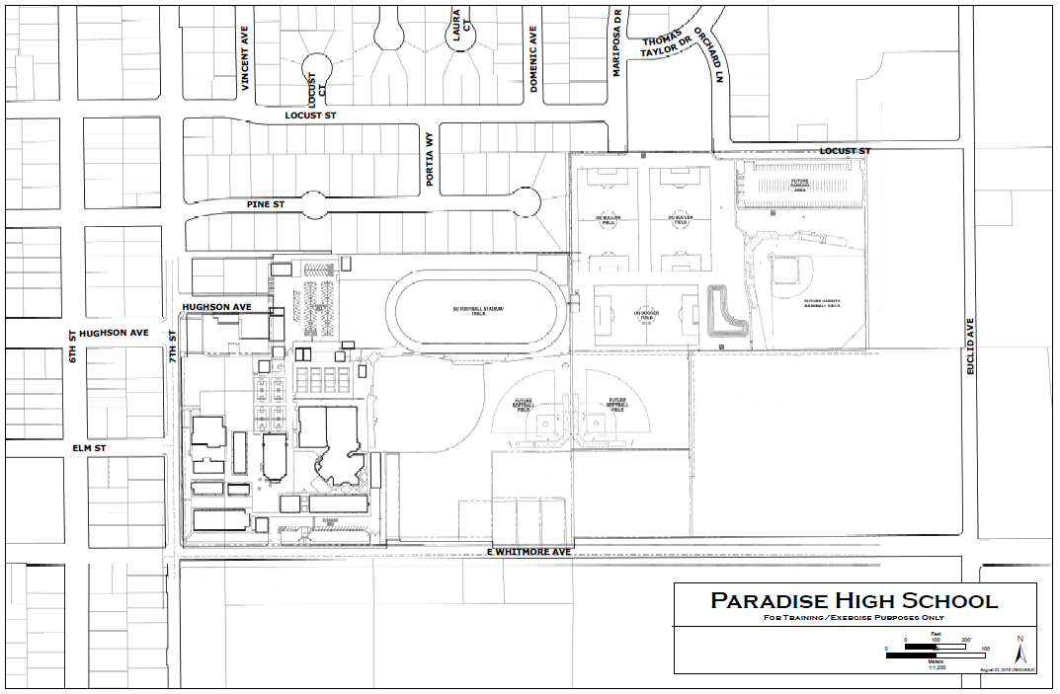

This page intentionally left blank

Appendix D: EMS/BRN Evaluation Form
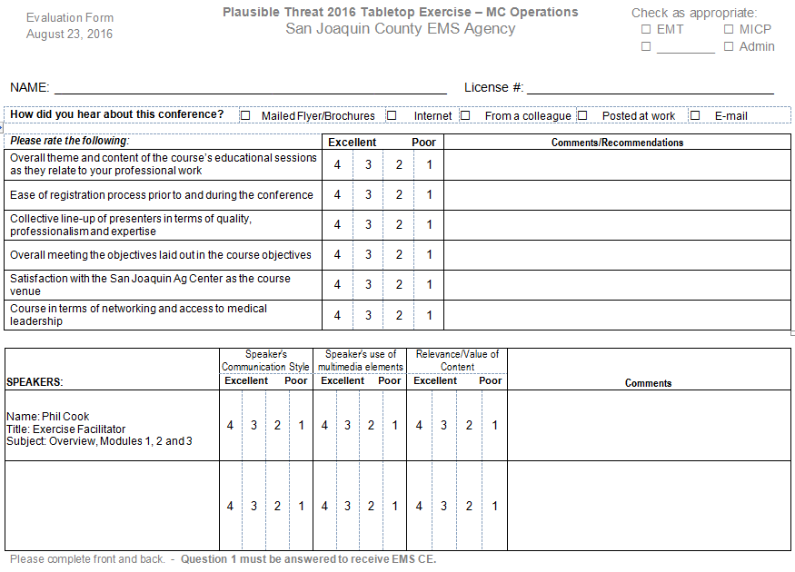
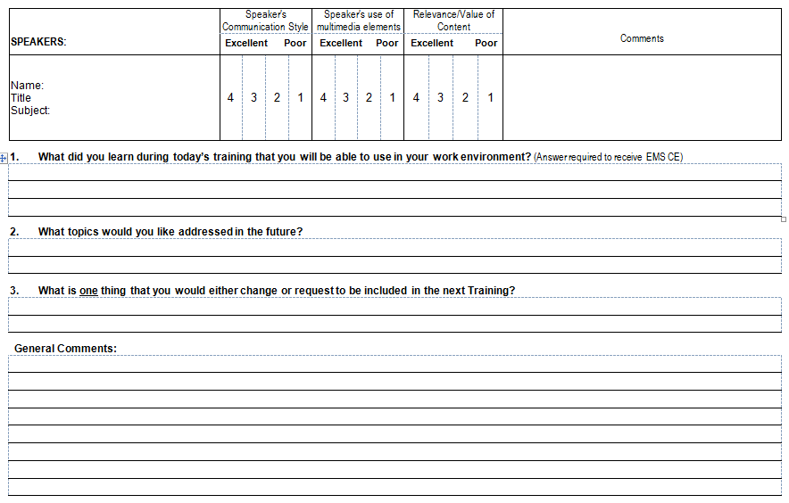

Appendix E: - Participant Feedback Form
Please enter your responses in the form field or check box after the appropriate selection.
Name: |  |  |  |  |  | Title:
Agency:
Role: | Player |  | Facilitator | Observer |  | Evaluator

Part I: Recommendations and Corrective Actions
- Based on the discussions today and the tasks identified, list the top three strengths and/or areas that need improvement.

- Identify the action steps that should be taken to address the issues identified above. For each action step, indicate if it is a high, medium, or low priority.
Corrective Action | Priority

- Describe the corrective actions that relate to your area of responsibility. Who should be assigned responsibility for each corrective action?
Corrective Action | Recommended Assignment

- List the policies, plans, and procedures that should be reviewed, revised, or developed. Indicate the priority level for each.
Item for Review | Priority

Part II: Assessment of Exercise Design and Conduct
Please rate, on a scale of 1 to 5, your overall assessment of the exercise relative to the statements provided below, with 1 indicating strong disagreement with the statement and 5 indicating strong agreement.
Assessment Factor | Strongly  Disagree |  |  | Strongly Agree
The exercise was well structured and organized. | 1 | 2 | 3 |  | 4 | 5
The exercise scenario was plausible and realistic. | 1 | 2 | 3 |  | 4 | 5
The multimedia presentation helped the participants understand and become engaged in the scenario. | 1 | 2 | 3 |  | 4 | 5
The facilitator(s) was knowledgeable about the material, kept the exercise on target, and was sensitive to group dynamics. | 1 | 2 | 3 |  | 4 | 5
The Situation Manual used during the exercise was a valuable tool throughout the exercise. | 1 | 2 | 3 |  | 4 | 5
Participation in the exercise was appropriate for someone in my position. | 1 | 2 | 3 |  | 4 | 5
The participants included the right people in terms of level and mix of disciplines. | 1 | 2 | 3 |  | 4 | 5

Part III: Participant Feedback
What changes would you make to this exercise? Please provide any recommendations on how this exercise or future exercises could be improved or enhanced.

https://www.fema.gov/mission-areas
https://www.fema.gov/core-capabilities
https://www.sjgov.org/ems/pdf/policies/7210activethreatplan(6-14-16).pdf

